FIT3146 - Emergent Technologies and Interfaces

Assignment 2: Progress Report - Pressure Alarm System

Student: Alvin Pang and Francis Nacional

Tutor: Jason Free

Tutorial: Thursday 1600-1800

## Abstract

## Table of Content

**Abstract** **1**

**Table of Content** **1**

**What has the team done so far?** **2**

**What does the team still have to do on the project/prototype?** **3**

**Will the project/prototype meet the deadline?** **3**

**Progress Video Link** **4**

## 

## 

## What has the team done so far?

The team has actually progressed well with the prototypes. The prototype design is very modular in nature, hence, the physical prototypes that the team has developed turned out quite well. There are currently two sensor prototypes that the team has developed. The main one uses the sponge/foil solution while another prototype is the permanent magnet/foil solution. Most of the materials used by the prototypes are easily obtainable and can be acquired cheaply. The only item that can be considered expensive that the design is currently using is the inverter. This is used in order to connect the prototypes to the mains power point. It will not be used when it is actually connected to a motor vehicle as it only requires 12 volts. Below are the photos of the sensor prototype modules and one of the sensors connected to the current test system.

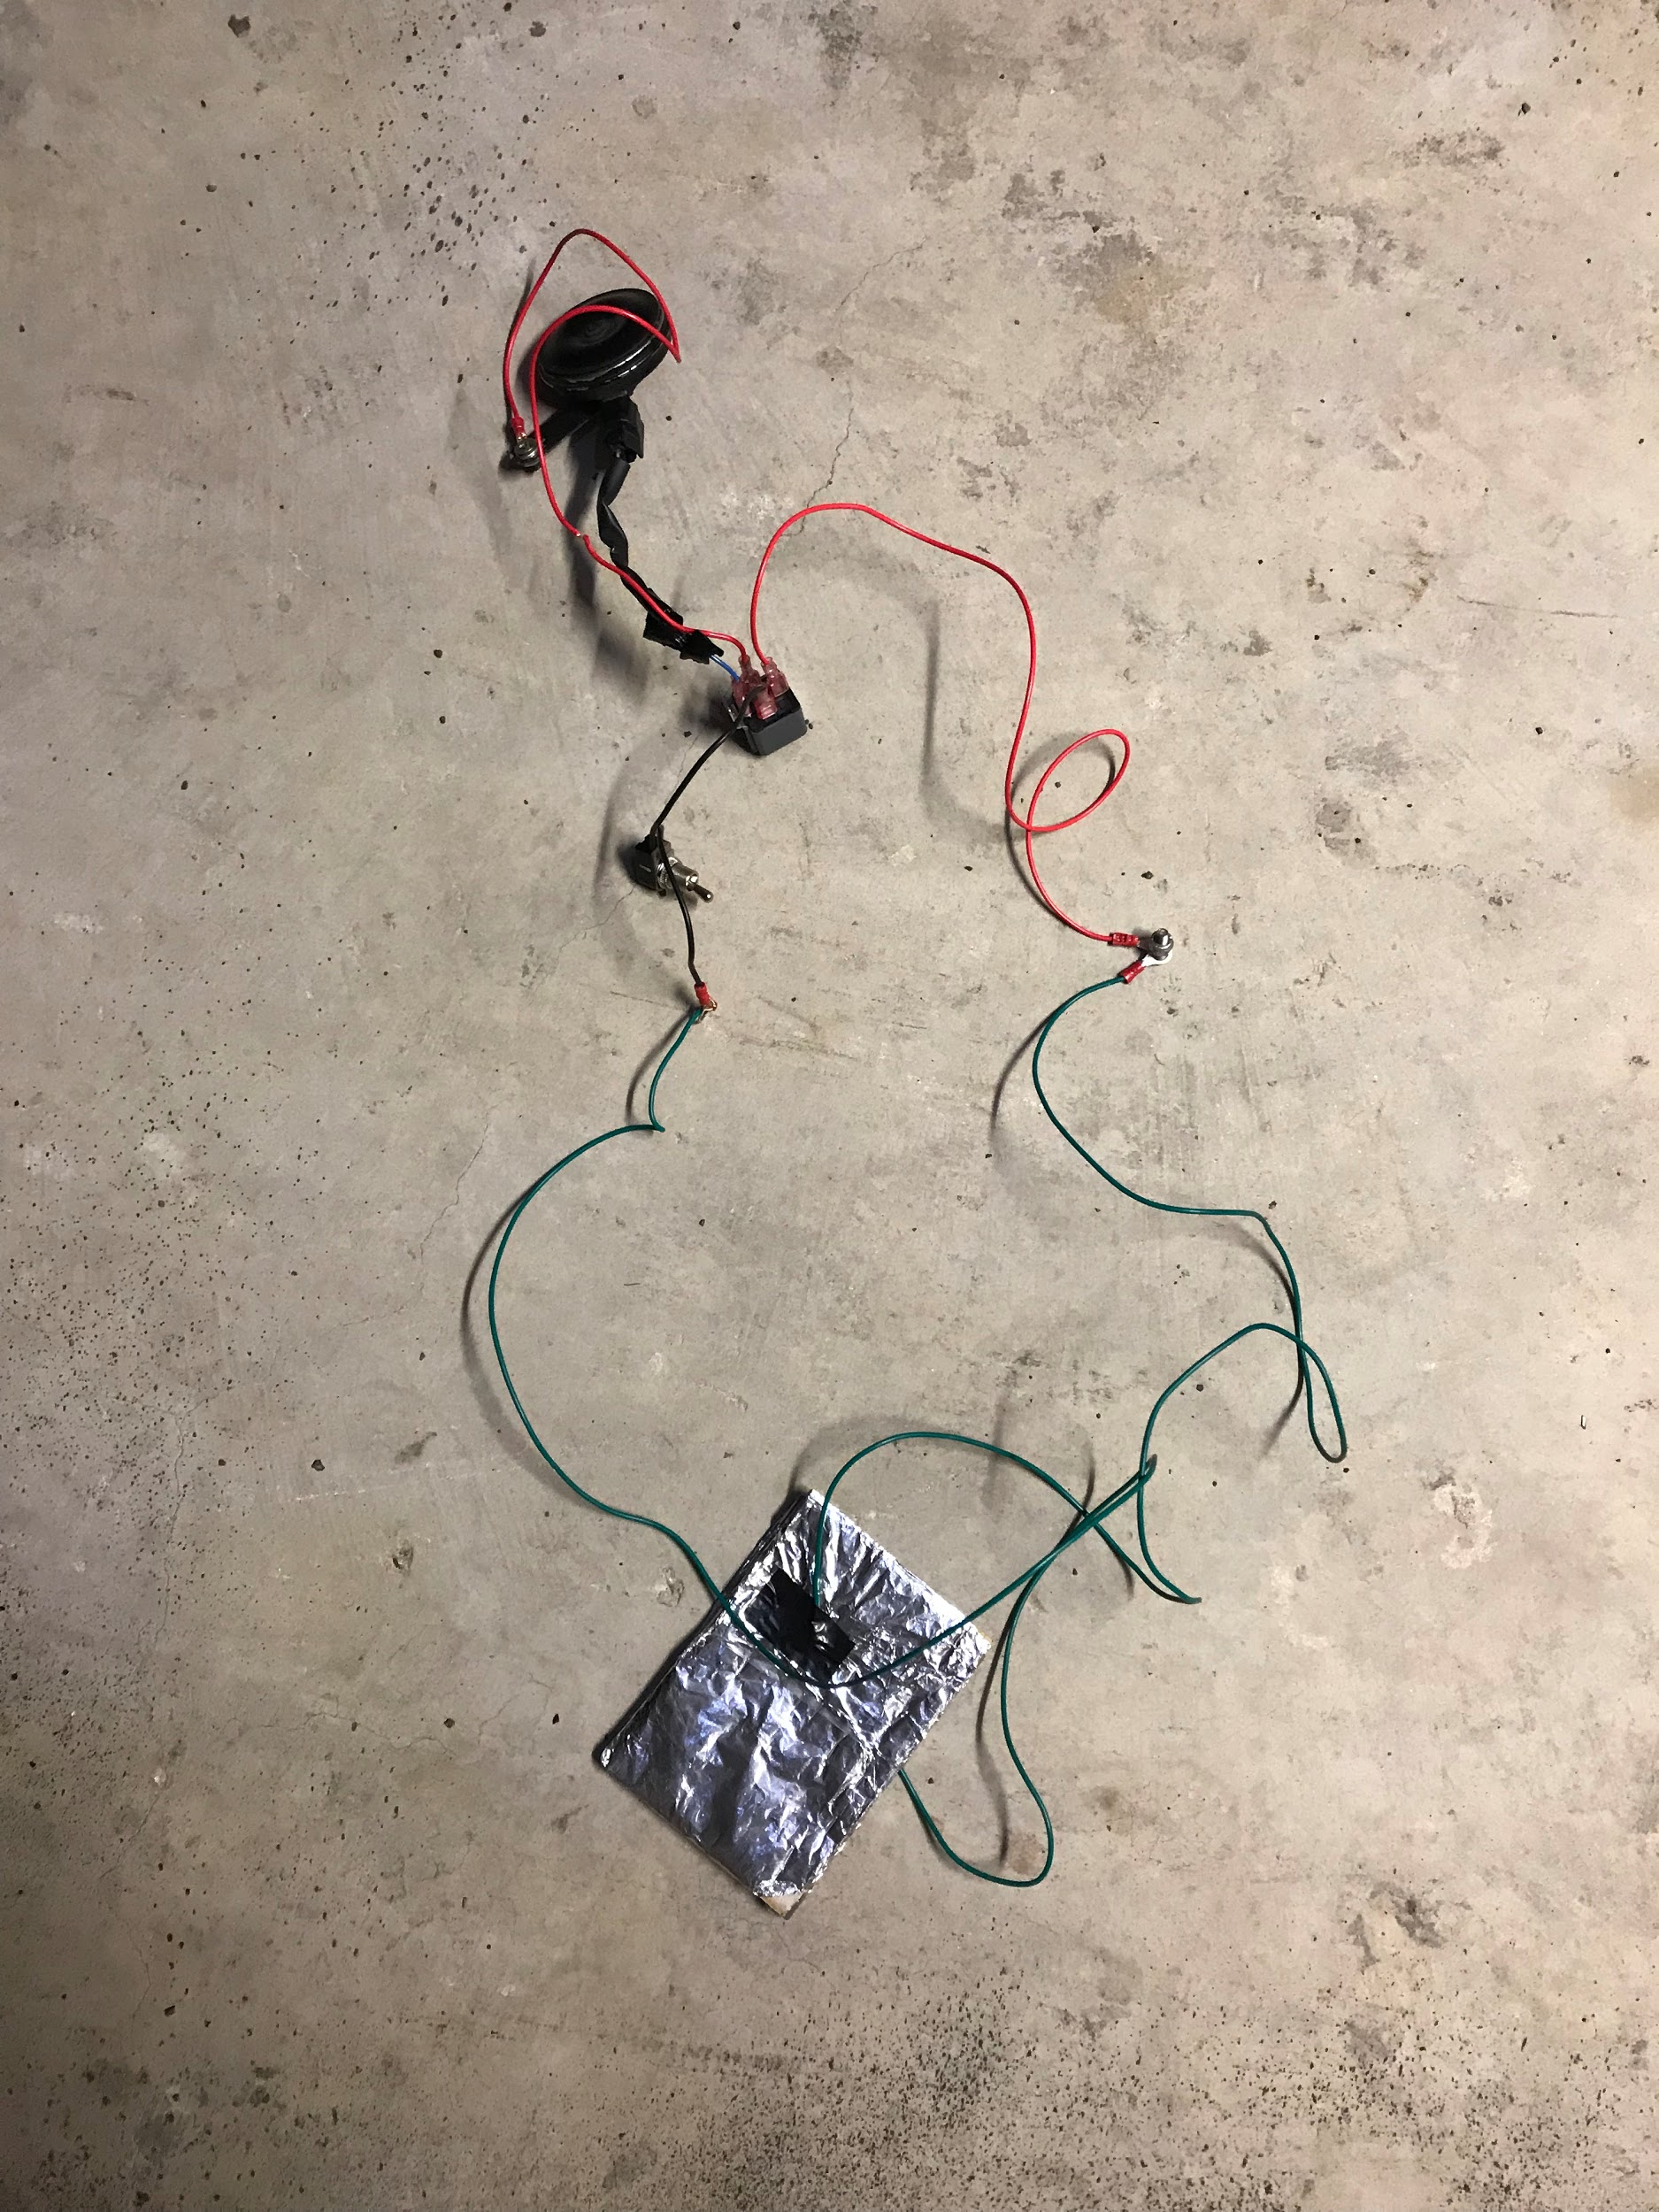

*Figure a. Actual prototype*

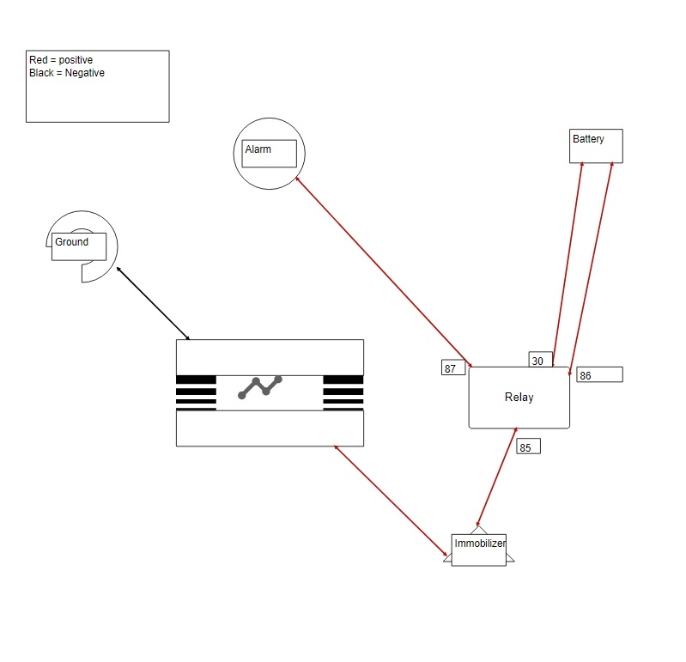

*Figure b. Design prototype.*

## What does the team still have to do on the project/prototype?

The team is currently awaiting the arrival of a GPS module which we have sourced from a Chinese online store. This module will enable the project to move to the second phase of the plan which is to enable the system to send an SMS notification to the owner’s mobile device as a secondary security measure complementing the initial security measures of the pressure sensor. The team also intends to further refine the prototypes. There are still things in the sensor that can be improved upon, such as the miniaturization of the sensor modules, and actually using an alarm and/or immobiliser system. We plan on testing the prototypes on an actual vehicle connecting the system to an actual live alarm will further our understanding on how to progress with the project.

## Will the project/prototype meet the deadline?

As it stands, the project will definitely meet the deadline. The only risk that the team is exposed to is if the GPS module arrives late or is lost in transit. Another risk that has been identified that may cause the project is the timing of week 15. It is exam times, and both members of the team have exams to study for and may leave little time to work on the project/prototype.

## Progress Video Link

Here is the video link that showcasing the prototypes: <https://www.youtube.com/watch?v=rpbcPEZqogw&feature=youtu.be>